Abstract:-

Portal for Farmers to sell the produce at a better rate • Problem statement in Description o System that provides farmers an interface to sell their produce , and connect with the buyers all over India o Simple interface that works on mobile, SMS to upload produce details and respond via phone and SMS (taking care of digital divide) o Interface for anyone to buy the produce/vegetable – initially visit the place and buy or have courier service integrated to deliver the vegetables o Farmers can get a better price for their produce, no additional cost spent in marketing and delivery of goods , however they can choose to charge more by delivering the items themselves • Purpose of this analysis and who will benefit o Farmers, Restaurant owners, Buyers , Courier Companies, Delivery Agencies, Vegetable Vendors • How does it help the nation o Better rates for the vegetables, Make the Farmers live with pride and make additional income • Practical and reasons why this idea could be a challenge o Brokers , Govt rules o Overall profitability in the deal for the buyer to purchase directly from farm , excluding transportation • How does this help CDK : What’s in it for us o No Direct link • Technology that can be used as a platform for connecting car buyer to Seller Domain Bucket o Agriculture o E-Commerce o Payment • Technology Bucket o Integration across systems – Integration platform across systems with security model for data extraction o SMS and Mobile Computing o Analytics & Data Science (if possible) - Bigdata/Hadoop, AI / ML o Data Aggregation o Visualization.

YouTube link : <https://www.youtube.com/watch?v=owp4L1e0aK0&t=165s>

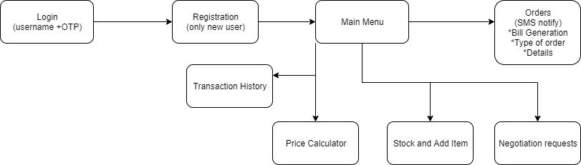

Fig 1.1 Farmer Module Work Flow

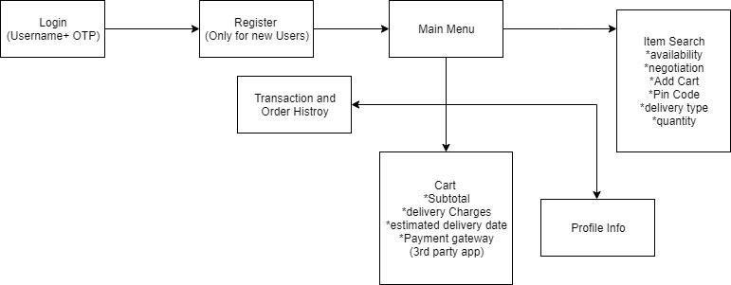

Fig 1.2 Customer Module Work Flow

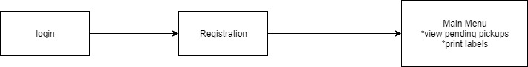

Fig 1.3 Delivery Module Work Flow